**ENCRYPTING TEXT IN IMAGES**

Installing steghide

* Enter the Command  
  “Apt install steghide”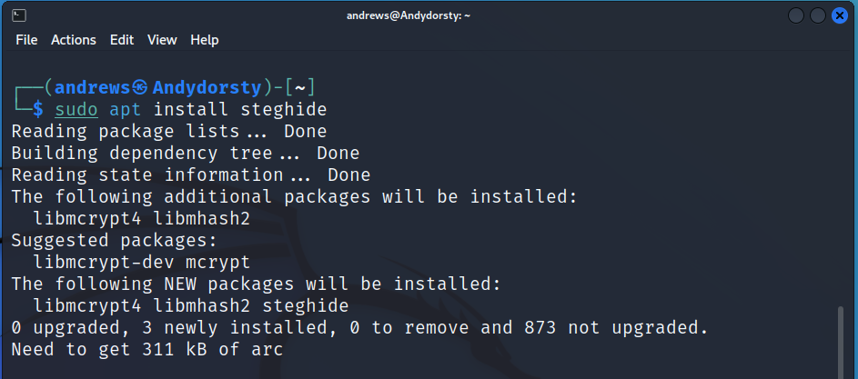
* Enter the Command to show proof of installation.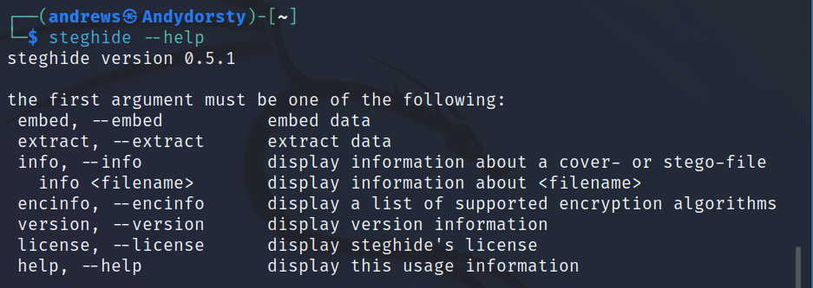

**ENCRYPTING A FILE(TEXT) IN A PICTURE USING STEGHIDE**

* Enter the following command to embed the plaintext in the image file.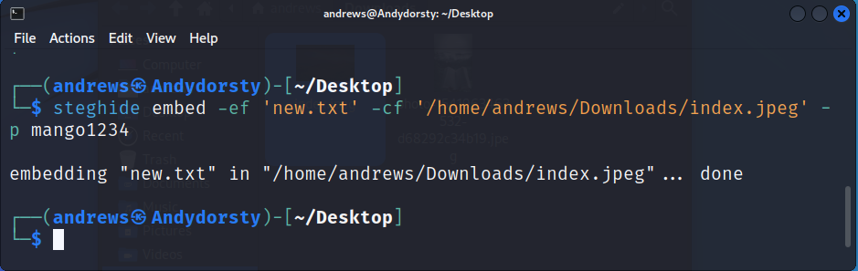



**The image with the embedded plaintext.**

* Extracting an embedded text from a picture.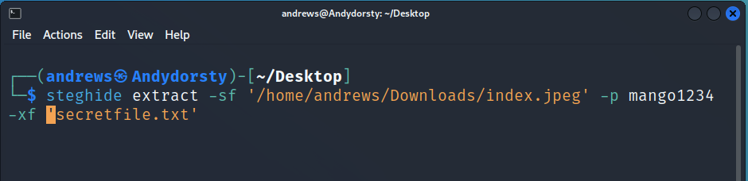

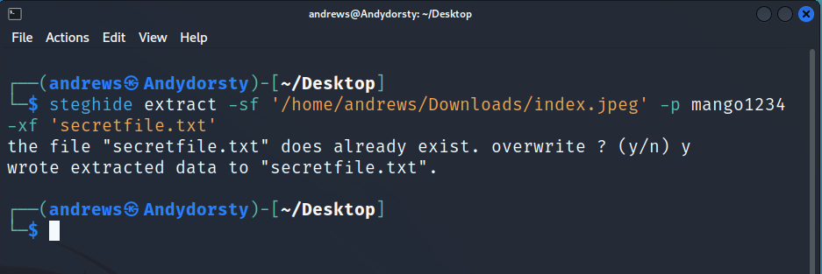

* Comparing the previous file and the new file.